|  |  |
| --- | --- |
| **Project Overview** |  |
| Objective | The primary objective is to streamline code translation between different programming languages, enhancing collaboration, reusability, and migration processes for developers. |
| Scope | The project aims to provide an efficient and accurate code translation tool that supports multiple programming languages, improving the workflow and productivity of development teams. |
| **Problem Statement** |  |
| Description | Current challenges in code translation include maintaining functionality and performance during platform transitions, facilitating multilingual collaboration, promoting code reusability, and addressing errors in translated code. These issues hinder operational efficiency and developer productivity.. |
| Impact | Addressing these challenges will lead to improved efficiency, seamless collaboration, enhanced code reusability, and reduced errors in translated code, ultimately contributing to better project outcomes and developer satisfaction. |
| **Proposed Solution** |  |
| Approach | Leveraging advanced AI and machine learning techniques to develop an AI-powered code translation tool that ensures accurate and efficient translation across different programming languages. |
| Key Features | 1. Implementation of an AI-driven code translation model. 2. Real-time code translation to support live collaboration. 3. Comprehensive library of translated code snippets and modules. 4. Automated error-checking and debugging tools. |

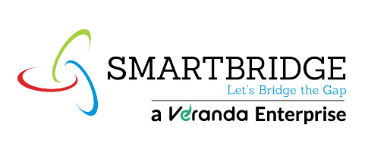**Project Initialization and Planning Phase**

|  |  |
| --- | --- |
| Date | 15 July 2024 |
| Team ID | SWTID1720075266 |
| Project Title | CodeXchange - AI-Powered Code Translation Tool |
| Maximum Marks | 3 Marks |

**Project Proposal (Proposed Solution) report**

The proposal report outlines the development of CodeXchange, an AI-powered code translation tool aimed at enhancing code translation accuracy and efficiency. By addressing current inefficiencies and challenges, CodeXchange promises to improve developer productivity, promote seamless collaboration, and ensure consistent code quality across different programming languages. Key features include an AI-driven translation model, real-time translation capabilities, a library of translated code snippets, and automated error-checking tools.

**Resource Requirements**

| **Resource Type** | **Description** | **Specification/Allocation** |
| --- | --- | --- |
| **Hardware** |  |  |
| Computing | CPU/GPU specifications, number of cores | T4 GPU |
| Memory | RAM specifications | 8 GB |
| Storage | Disk space for data, models, and logs | 1 TB SSD |
| **Software** |  |  |
| Frameworks | Python frameworks | Flask |
| Libraries | Additional libraries | scikit-learn, pandas, numpy, matplotlib, seaborn |
| Development Env. | IDE | Jupyter Notebook, PyCharm |
| **Data** |  |  |
| Data | Source, size, format | GitHub repositories, varied sizes, multiple formats |